**FUTABA SBUS** – digital data stream

Serial data has rest state at 0v; Baud Rate 100k; 8 data bits; Even parity; 2 stop bits. LSB first.

The received channel data segment is 25 bytes long and starts with 0x0F and ends with 0x00. The data is sent every 15mS.

Byte 0 = 0x0F.

Bytes 1 to 22 contains 16 data channels each of 11 bits.

Byte 23 contains 2 digital data channels and status information.

Byte 24 contains 0x00.

**NOTE**: Images are Inverted and Least Significant Bit first with the decoded value correctly interpreted.

SBUS Data Stream

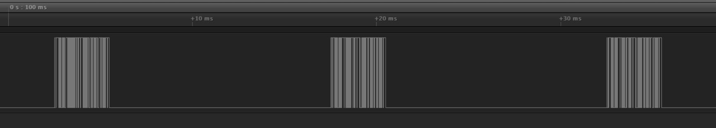

SBUS Data Stream showing Start Byte = 0x0F

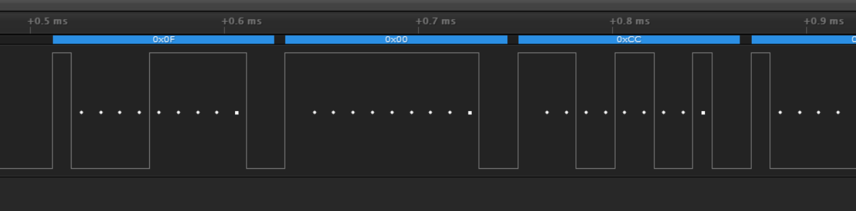

SBUS Data Stream showing Frame0 last byte = 0x00.

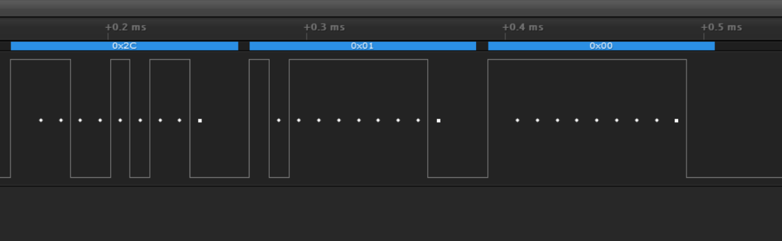

**FUTABA SBUS2** FASSTest 18CH – digital data stream with telemetry.

Serial data has rest state at 0v; Baud Rate 100k; 8 data bits; Even parity; 2 stop bits.

Once the data stream has been sent by the receiver to SBUS2 it places itself in SBUS receive mode ready to accept Sensor information. Slot0 is the only exception as it is sent by the receiver.

Data stream consists of 4 Frames each with 8 Slots for Sensor data. Slot 0 is reserved for and used by the receiver. The received channel data segment is 25 bytes long and starts with 0x0F and ends with 0x04, 0x014, 0x24 or 0x34. The end byte defines the Frame; 0, 1, 2 or 3.

Frame 0 sensor slots: 0, 1, 2, 3, 4, 5, 6, 7.

Frame 1 sensor slots: 8, 9, 10, 11, 12, 13, 14, 15.

Frame 2 sensor slots: 16, 17, 18, 19, 20, 21, 22, 23.

Frame 3 sensor slots: 24, 25, 26, 27, 28, 29, 30, 31.

The data is repeated every 15mS.

Byte 0 = 0x0F.

Bytes 1 to 22 contains 16 data channels each of 11 bits.

Byte 23 contains 2 digital data channels and status information.

Byte 24 contains 0x04, 0x14, 0x24 or 0x34.

**NOTE**: Images are Inverted and Least Significant Bit first with the decoded value correctly interpreted.

SBUS2 Data Stream showing all 4 Frames and SLOT0 data.

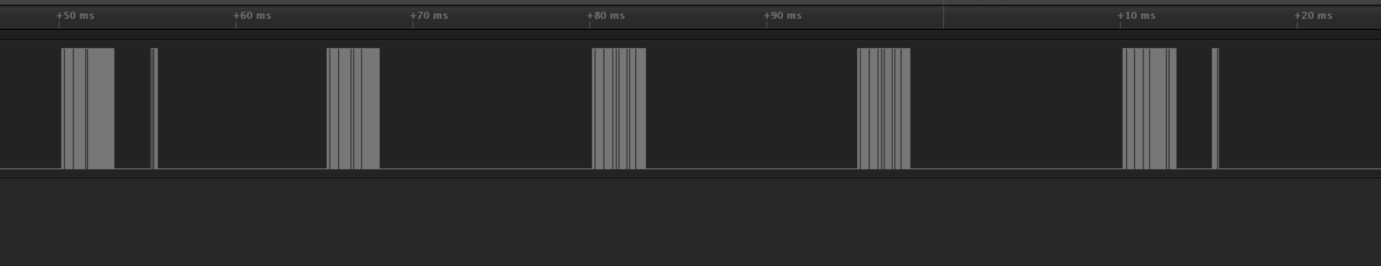

SBUS2 Data Stream showing Start Byte = 0x0F

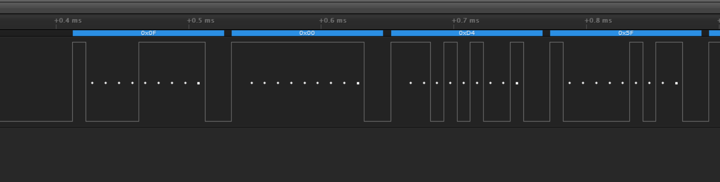

SBUS2 Data Stream showing Frame0 last byte = 0x04.

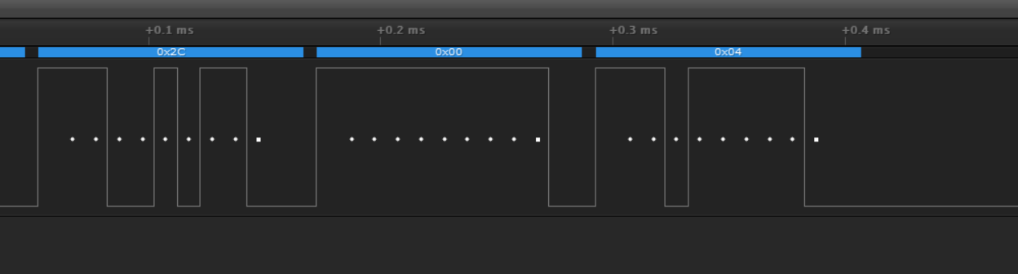

SBUS2 Data Stream showing Frame1 last byte = 0x14.

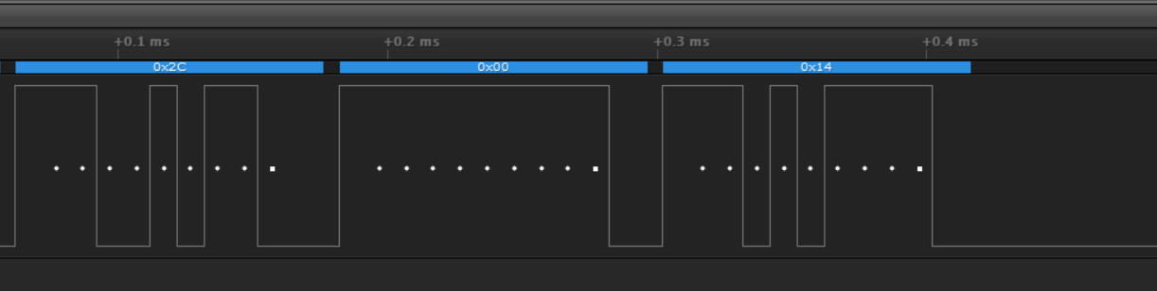

SBUS2 Data Stream showing all Sensor Slots occupied.

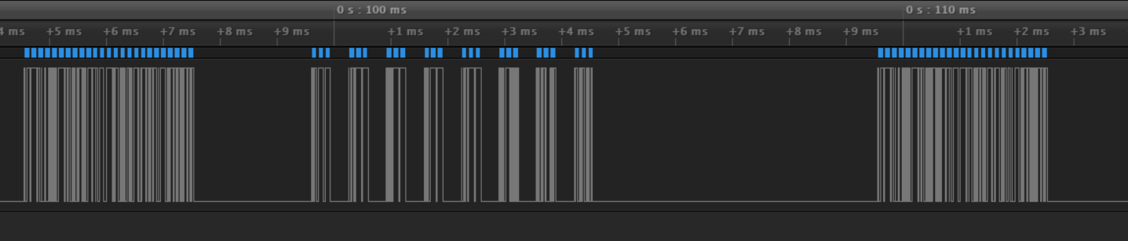

2mS separates the end of the last byte of the data stream and the start bit of the first sensor data.

320uS separates the end of the third byte of the sensor and the start bit of the first byte of the next sensor. Each Sensor window width is 660uS.

5mS separates the end of the third byte of the eighth sensor and the start of the next data stream.

**SBUS2 Slot0:**

Slot0 is solely for receiver use. It contains receiver status information and multiplexes internal and external battery voltage. First data byte bit 3 indicates which battery voltage byte 2 contains.

**NOTE**: Images are Inverted and Least Significant Bit first with the decoded value correctly interpreted.

Figure shows Slot0, No Signal, External Battery:

Receiver supplied SLOT0. First byte is slot address 0x03; Second byte contains Signal Quality in the first 2 Most Significant Data Bits 0x04 and Bit 3 = 1 indicating Last Byte contains external battery voltage 0x00 (== 0.0V).

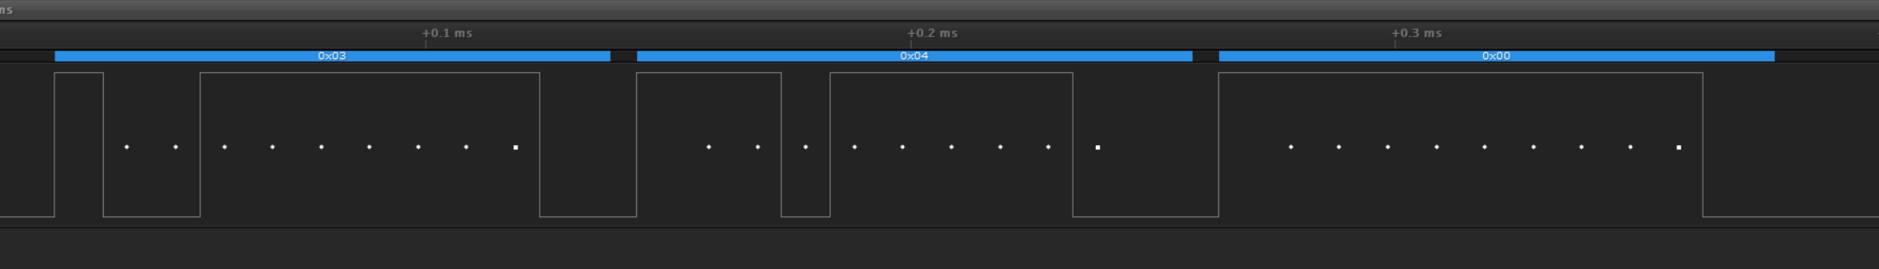

Figure shows Slot0, Good Signal, Internal Battery:

Receiver supplied SLOT0. First byte is slot address 0x03; Second byte contains Signal Quality in the first 2 Most Significant Data Bits 0xC0. Bit 3 = 0 indicating Last Byte contains internal battery voltage 0x2F (== 4.7V).

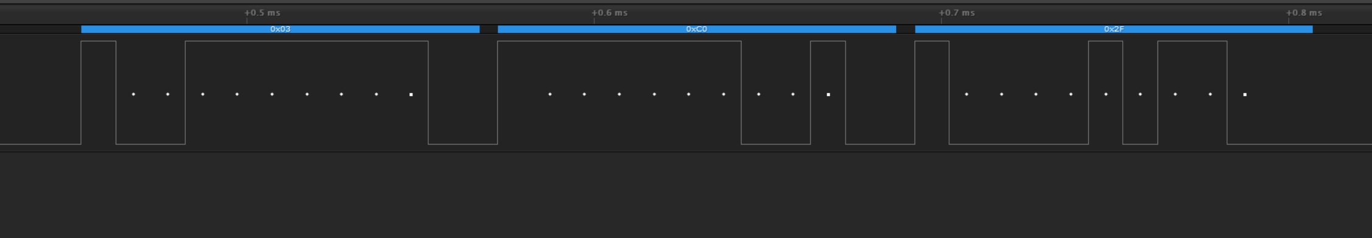

**Sensor Data:**

Data is sent as a coded 3 Byte sequence for each sensor.

**NOTE**: Images are Inverted and Least Significant Bit first with the decoded value correctly interpreted.

Shown are three occupied sensor slots.

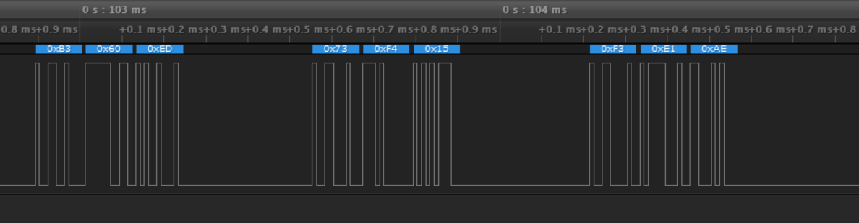

The first byte is the Sensor Slot Address followed by the 2-byte data fields.

Sensor address formatting is as follows:

Bits 0 and 1 must each hold a ‘1’ signifying this is a slot address byte. The remaining 6 bits hold the sensor address in bit reverse order.

i.e., bit 7 holds address bit 0, bit six address bit 1, …. with bit 3 holding address bit 4.

e.g., 0xB3 = 10110011 where the address identifier is the 3 and 0xB0 = 10110 in reverse order is

01101 = 0x0D = 13. Address byte for slot 13. Information for slot 14 and 15 is also shown.

The transmitter is configured with the sensor type to expect for each occupied slot. Some, but not all sensors have bits allocated within the data field to define the sensor type.

Sensors can occupy a number of slots and as the transmitter knows the number of slots required and will allow only appropriate slot assignments which will accommodate the sensor information within a Frame.

e.g., Futaba GPS uses 8 slots so can be assigned only 8, 16 or 24.

**FUTABA FASSTest 12CH** – digital data stream

Serial data has rest state at 0v; Baud Rate 100k; 8 data bits; Even parity; 2 stop bits. LSB first.

Data stream consists of 1 Frame with 1 Slot; Slot0 used by the receiver. No sensor data slots are available.

The received channel data segment is 25 bytes long and starts with 0x0f and ends with 0x00. The data is sent every 6.3mS.

Byte 0 = 0x0f.

Bytes 1 to 22 contains 12 data channels each of 11 bits.

Byte 23 contains 2 digital data channels.

Byte 24 contains 0x08.

**NOTE**: Images are Inverted and Least Significant Bit first with the decoded value correctly interpreted.

Shown is the data with timing.

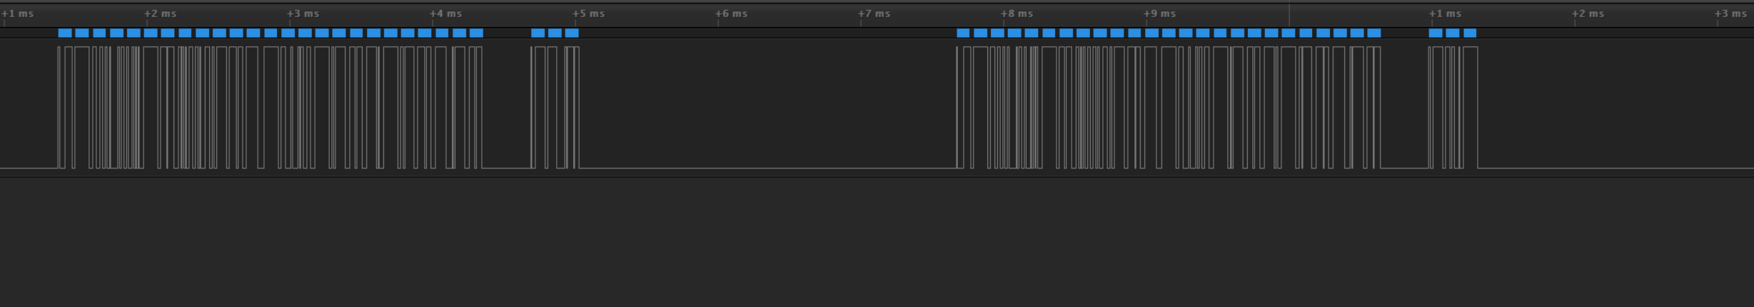

Shown is the last byte 0x08

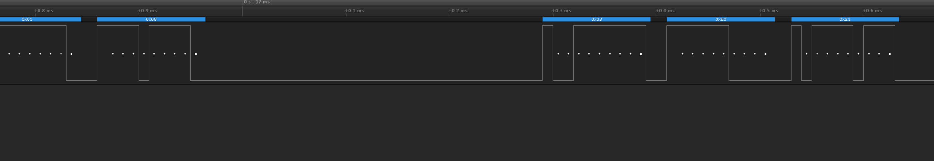

**Sensors Described:**

Slots available are 1 to 31 and using the FUTABA address format where bits 0 and 1 set to ‘1’ with bits 3 – 7 containing the reversed 6 bit address we get the following:

**SLOT addressing:**

**Frame0** **Frame2**

0000 0011 - Slot0 – 0x03 0000 1011 - Slot16 – 0x0B

1000 0011 - Slot1 – 0x83 1000 1011 - Slot17 – 0x8B

0100 0011 - Slot2 – 0x43 0100 1011 - Slot18 – 0x4B

1100 0011 - Slot3 – 0xC3 1100 1011 - Slot19 – 0xCB

0010 0011 - Slot4 – 0x23 0010 1011 - Slot20 – 0x2B

1010 0011 - Slot5 – 0xA3 1010 1011 - Slot21 – 0xAB

0110 0011 - Slot6 – 0x63 0110 1011 - Slot22 – 0x6B

1110 0011 - Slot7 – 0xE3 1110 1011 - Slot23 – 0xEB

**Frame1** **Frame3**

0001 0011 - Slot8 – 0x13 0001 1011 - Slot24 – 0x1B

1001 0011 - Slot9 – 0x93 1001 1011 - Slot25 – 0x9B

0101 0011 - Slot10 – 0x53 0101 1011 - Slot26 – 0x5B

1101 0011 - Slot11 – 0xD3 1101 1011 - Slot27 – 0xDB

0011 0011 - Slot12 – 0x33 0011 1011 - Slot28 – 0x3B

1011 0011 - Slot13 – 0xB3 1011 1011 - Slot29 – 0xBB

0111 0011 - Slot14 – 0x73 0111 1011 - Slot30 – 0x7B

1111 0011 - Slot15 – 0xF3 1111 1011 - Slot31 – 0xFB

Three bytes of Sensor data will be described as **<slot><data0><data1>**

In the case of sensors requiring more than one slot the slot offset will be annotated with slot+0 being the assigned slot and remainder using slot+1, …. slot+n.

**FUTABA GPS SBS-02G:**

Transmitter configures as GPS.

|  |  |  |  |  |  |  |  |  |  |  |  |  |  |  |  |  |  |  |  |  |  |  |  |  |  |  |  |  |  |  |  |  |  |  |  |  |  |  |  |  |  |  |  |  |  |  |  |  |  |  |  |  |  |  |  |  |  |  |  |  |  |  |  |  |  |  |  |  |  |  |  |  |  |  |  |  |  |  |  |  |  |  |  |  |  |  |  |  |  |  |  |  |  |  |  |  |  |  |  |  |  |  |  |  |  |  |  |  |  |  |  |  |  |  |  |  |  |  |  |  |  |  |  |  |  |  |  |  |  |  |  |  |  |  |  |  |  |  |  |  |  |  |  |  |  |  |  |  |  |  |  |  |  |  |  |  |  |  |  |  |  |  |  |  |  |  |  |  |  |  |  |  |  |  |  |  |  |  |  |  |  |  |  |  |  |  |  |  |  |  |  |  |  |  |  |  |  |  |  |  |  |  |  |  |  |  |  |  |  |  |  |  |  |  |  |  |  |  |  |  |  |  |  |  |  |  |  |  |  |  |  |  |  |  |  |  |  |  |  |  |  |  |  |  |  |  |  |  |  |  |  |  |  |  |  |  |  |  |  |  |  |  |  |  |  |  |  |  |  |  |  |  |  |  |  |  |
| --- | --- | --- | --- | --- | --- | --- | --- | --- | --- | --- | --- | --- | --- | --- | --- | --- | --- | --- | --- | --- | --- | --- | --- | --- | --- | --- | --- | --- | --- | --- | --- | --- | --- | --- | --- | --- | --- | --- | --- | --- | --- | --- | --- | --- | --- | --- | --- | --- | --- | --- | --- | --- | --- | --- | --- | --- | --- | --- | --- | --- | --- | --- | --- | --- | --- | --- | --- | --- | --- | --- | --- | --- | --- | --- | --- | --- | --- | --- | --- | --- | --- | --- | --- | --- | --- | --- | --- | --- | --- | --- | --- | --- | --- | --- | --- | --- | --- | --- | --- | --- | --- | --- | --- | --- | --- | --- | --- | --- | --- | --- | --- | --- | --- | --- | --- | --- | --- | --- | --- | --- | --- | --- | --- | --- | --- | --- | --- | --- | --- | --- | --- | --- | --- | --- | --- | --- | --- | --- | --- | --- | --- | --- | --- | --- | --- | --- | --- | --- | --- | --- | --- | --- | --- | --- | --- | --- | --- | --- | --- | --- | --- | --- | --- | --- | --- | --- | --- | --- | --- | --- | --- | --- | --- | --- | --- | --- | --- | --- | --- | --- | --- | --- | --- | --- | --- | --- | --- | --- | --- | --- | --- | --- | --- | --- | --- | --- | --- | --- | --- | --- | --- | --- | --- | --- | --- | --- | --- | --- | --- | --- | --- | --- | --- | --- | --- | --- | --- | --- | --- | --- | --- | --- | --- | --- | --- | --- | --- | --- | --- | --- | --- | --- | --- | --- | --- | --- | --- | --- | --- | --- | --- | --- | --- | --- | --- | --- | --- | --- | --- | --- | --- | --- | --- | --- | --- | --- | --- | --- | --- | --- | --- | --- | --- | --- | --- | --- | --- | --- | --- | --- | --- | --- | --- | --- | --- | --- |
| |  |  |  |  |  |  |  |  |  |  |  | | --- | --- | --- | --- | --- | --- | --- | --- | --- | --- | --- | | Slot offset | Data byte |  | bit 7 | bit 6 | bit 5 | bit 4 | bit 3 | bit 2 | bit 1 | bit 0 | |  |  |  |  |  |  |  |  |  |  |  | | GPS+0 | 0 |  | UTC 7 | UTC 6 | UTC 5 | UTC 4 | UTC 3 | UTC 2 | UTC 1 | UTC 0 | |  | 1 |  | UTC 15 | UTC 14 | UTC 13 | UTC 12 | UTC 11 | UTC 10 | UTC 9 | UTC 8 | |  |  |  |  |  |  |  |  |  |  |  | | GPS+1 | 0 |  | LAT 6 | LAT 5 | LAT 4 | LAT3 | LAT 2 | LAT 1 | LAT 0 | UTC 16 | |  | 1 |  | LAT 14 | LAT 13 | LAT 12 | LAT 11 | LAT 10 | LAT 9 | LAT 8 | LAT 7 | |  |  |  |  |  |  |  |  |  |  |  | | GPS+2 | 0 |  | LAT 22 | LAT 21 | LAT 20 | LAT 19 | LAT 18 | LAT 17 | LAT 16 | LAT 15 | |  | 1 |  | LNG 3 | LNG 2 | LNG 1 | LNG 0 | LAT Sign | LAT 25 | LAT 24 | LAT 22 | |  |  |  |  |  |  |  |  |  |  |  | | GPS+3 | 0 |  | LNG 11 | LNG 10 | LNG 9 | LNG 8 | LNG 7 | LNG 6 | LNG 5 | LNG 4 | |  | 1 |  | LNG 19 | LNG 18 | LNG 17 | LNG 16 | LNG 15 | LNG 14 | LNG 13 | LNG 12 | |  |  |  |  |  |  |  |  |  |  |  | | GPS+4 | 0 |  | LNG Sign | LNG 26 | LNG 25 | LNG 24 | LNG 23 | LNG 22 | LNG 21 | LNG 20 | |  | 1 |  | SPD 7 | SPD 6 | SPD 5 | SPD 4 | SPD 3 | SPD 2 | SPD 1 | SPD 0 | |  |  |  |  |  |  |  |  |  |  |  | | GPS+5 | 0 |  | BARO 2 | BARO 1 | BARO 0 | XXX | SAT 1 | SAT 0 | GPS FIX | SPD 8 | |  | 1 |  | BARO 10 | BARO 9 | BARO 8 | BARO 7 | BARO 6 | BARO 5 | BARO 4 | BARO 3 | |  |  |  |  |  |  |  |  |  |  |  | | GPS+6 | 0 |  | ALT 4 | ALT 3 | ALT 2 | ALT 1 | ALT 0 | BARO 13 | BARO 12 | BARO 11 | |  | 1 |  | ALT 12 | ALT 11 | ALT 10 | ALT 9 | ALT 8 | ALT 7 | ALT 6 | ALT 5 | |  |  |  |  |  |  |  |  |  |  |  | | GPS+7 | 0 |  | VARO 4 | VARO 3 | VARO 2 | VARO 1 | VARO 0 | ALT 15 | ALT 14 | ALT 13 | |  | 1 |  | BARO OK | VARO 11 | VARO 10 | VARO 9 | VARO 8 | VARO 7 | VARO 6 | VARO 5 | |  |
|  |  |
|  |  |
|  |  |
|  |  |
|  |  |
|  |  |
|  |  |
|  |  |
|  |  |
|  |  |
|  |  |
|  |  |
|  |  |
|  |  |
|  |  |
|  |  |
|  |  |
|  |  |
|  |  |
|  |  |
|  |  |
|  |  |
|  |  |
|  |  |
|  |  |

The above chart designates the information encoded into the 8 slots used by the GPS sensor.

UTC – stored in seconds.

LATitude – stored in 1/12e5 degrees. Negative sign for South.

LoNGitude – stored in 1/6e5 degrees. Negative sign for West.

SPeeD – Range 511Km/Hr; resolution 1Km/Hr.

GPS FIX – 1 = fix; 0 = no fix.

SATellites – unspecified; 0, 1, 2 or 3.

XXX – Unresolved. Set to ‘0’ as would crash my Transmitter when ‘1’. Recent release resolved issue.

BAROmeter - - 0.0 to 1638.3

ALTitude – Range 6553.3m. -1638.3m to 4915.2m for 0x0000 – 0xFFFF. Transmitter sets 0 for first reading and each step is 0.1m.

VARIOmeter – Range -150.0m/s to +259.5m/s; resolution 0.1m/s.

BARO OK – must be 1 for barometric functions to have data reported.

**FUTABA Temperature SBS-01TE**

Transmitter configures as Temperature.

Occupies 1 slot.

Sensor Data Format: <slot number> <byte0> <byte1>

<byte1> must have bit 7 set to ‘1’

|  |  |  |  |  |  |  |  |  |  |
| --- | --- | --- | --- | --- | --- | --- | --- | --- | --- |
| Slot offset | Data byte | bit 7 | bit 6 | bit 5 | bit 4 | bit 3 | bit 2 | bit 1 | bit 0 |
|  |  |  |  |  |  |  |  |  |  |
| Temp+0 | 0 | TMP7 | TMP6 | TMP5 | TM4 | TM3 | TMP2 | TMP1 | TMP0 |
|  | 1 | 1' | TMP14 | TMP13 | TMP12 | TMP11 | TMP10 | TMP9 | TMP8 |

Display range starts at -100C for data = 0 hence an offset of 100 is required for all values.

Sensor Data Format: <slot number> <byte0> <byte1 | 0x80>

Data range -100 to 9999 <slot><00><80> to <slot><73><27 | 0x80>

**ROBBE Temperature Sensor TEMP-F1713 Sensor**

Transmitter configures as Temp-F1713

Occupies 1 slot.

Sensor Data Format: <slot number> <byte0> <byte1>

<byte0> must have bit 6 set to ‘1’

|  |  |  |  |  |  |  |  |  |  |
| --- | --- | --- | --- | --- | --- | --- | --- | --- | --- |
| Slot offset | Data byte | bit 7 | bit 6 | bit 5 | bit 4 | bit 3 | bit 2 | bit 1 | bit 0 |
|  |  |  |  |  |  |  |  |  |  |
| Temp+0 | 0 |  | 1' | TMP13 | TM12 | TM11 | TMP10 | TMP9 | TMP8 |
|  | 1 | TMP7 | TMP6 | TMP5 | TMP4 | TMP3 | TMP2 | TMP1 | TMP0 |

Data range 0 to +9999 <slot><00 | 0x40><00> to <slot><67><0F>

-1 to -9999 <slot><0xB0 | 0x40 ><FF> to <slot><0x98 | 0x40><F1> i.e., 2's compliment.

**FUTABA RPM sensor**

Transmitter configures as rpm sensor then configures sensor parameters.

Occupies 1 slot.

Sensor Data Format: <slot number> <byte0> <byte1>

sensor parameters: Sensor type = magnet; Gear ratio = 6.00. Data now appears as loaded.

byte0 is MSB with byte1 LSB.

Data range 0 to 65535 <slot><00><00> to <slot><FF><FF>

Note: With a 'Gear Ratio = 1.0' selected data range is 0rpm to 393210rpm in 6rpm increments.

Readers can experiment with all the other options as required.

**VARIO-F1712**

<slot number +1 ><byte0> must have bit 6 set to ‘1’ to enable both slots.

Occupies 2 slots. Slot+0 Variometer and Slot+1 Altimeter.

Sensor Data Format: <slot number> <byte0> <byte1>

Sensor Data Format: <slot number +1 > <byte0 | 0x40> <byte1>

Variometer:

Byte0 MSB, Byte1 LSB.

Range -999.9 to 999.9, 2's compliment.

Altimeter:

Byte0 MSB, Byte1 LSB.

Altimeter requires byte 0 bit 6 must be '1' to enable SENSOR.

Sensor Data Format: <slot number+1><byte0 | 0x40><byte1>

Range -16384 to 16383, 2's compliment. Transmitter sets zero on first reading.

|  |  |  |  |  |  |  |  |  |  |
| --- | --- | --- | --- | --- | --- | --- | --- | --- | --- |
| Slot offset | Data byte | bit 7 | bit 6 | bit 5 | bit 4 | bit 3 | bit 2 | bit 1 | bit 0 |
|  |  |  |  |  |  |  |  |  |  |
| Vario+0 | 0 | VAR15 | VAR14 | VAR13 | VAR12 | VAR11 | VAR10 | VAR9 | VAR8 |
|  | 1 | VAR7 | VAR6 | VAR5 | VAR4 | VAR3 | VAR2 | VAR1 | VAR0 |
|  |  |  |  |  |  |  |  |  |  |
| Vario+1 | 0 | SIGN | 1' | TMP13 | TM12 | ALT11 | ALT10 | ALT9 | ALT8 |
|  | 1 | ALT7 | ALT6 | ALT5 | ALT4 | ALT3 | ALT2 | ALT1 | ALT0 |

**VARIO-F1672**

<slot number +1 ><byte0> must have bit 6 set to ‘1’

Occupies 2 slots. Slot+0 Variometer and Slot+1 Altimeter.

Sensor Data Format: <slot number> <byte0> <byte1>

Sensor Data Format: <slot number +1 > <byte0 | 0x40> <byte1>

Variometer:

Byte0 high, Byte1 low.

Range -327.68 to 327.66, 2's compliment.

Altimeter:

Altimeter requires byte 0 bit 6 be set to '1' to enable SENSOR.

Sensor Data Format: <slot number+1><byte0 | 0x40><byte1>

Range -16384 to 16383, 2's compliment. Transmitter sets zero on first reading.

|  |  |  |  |  |  |  |  |  |  |
| --- | --- | --- | --- | --- | --- | --- | --- | --- | --- |
| Slot offset | Data byte | bit 7 | bit 6 | bit 5 | bit 4 | bit 3 | bit 2 | bit 1 | bit 0 |
|  |  |  |  |  |  |  |  |  |  |
| Vario+0 | 0 | VAR15 | VAR14 | VAR13 | VAR12 | VAR11 | VAR10 | VAR9 | VAR8 |
|  | 1 | VAR7 | VAR6 | VAR5 | VAR4 | VAR3 | VAR2 | VAR1 | VAR0 |
|  |  |  |  |  |  |  |  |  |  |
| Vario+1 | 0 | SIGN | 1' | TMP13 | TM12 | ALT11 | ALT10 | ALT9 | ALT8 |
|  | 1 | ALT7 | ALT6 | ALT5 | ALT4 | ALT3 | ALT2 | ALT1 | ALT0 |

|  |  |  |  |  |  |  |  |  |
| --- | --- | --- | --- | --- | --- | --- | --- | --- |
|  |  |  |  |  |  |  |  |  |

**CURRENT**

Occupies 3 slots. <slot+0> Current, <slot+1> Voltage and <slot+2> Capacity.

<slot number +0 ><byte0> must have bit 6 set to ‘1’ to enable three slots.

Current:

<slot+0 >; byte 0 requires bit 6 be '1' to enable SENSOR.

Byte0 MSB, Byte1 LSB. Byte1 bits 5 - 0 not used.

Sensor Data Format: <slot number+0><byte0 | 0x40><byte1>

Range -163A to 163A

Voltage:

Byte0 MSB, Byte1 LSB. Byte1 bits 3 - 0 not used.

<slot+1> Voltage: byte0 bits 2 - 0 not used.

Sensor Data Format: <slot number+0><byte0><byte1>

Range +-99.9V, data is scaled by 12.5.

i.e., 1volt is loaded as 1 x 12.5 rounded up to 13 to display 1.0V

Capacity:

Byte0 high, Byte1 low.

Slot+2 mAHr -32768 to 32766

|  |  |  |  |  |  |  |  |  |  |
| --- | --- | --- | --- | --- | --- | --- | --- | --- | --- |
| Slot offset | Data byte | bit 7 | bit 6 | bit 5 | bit 4 | bit 3 | bit 2 | bit 1 | bit 0 |
|  |  |  |  |  |  |  |  |  |  |
| Current+0 | 0 |  | 1' | CUR7 | CUR6 | CUR5 | CUR4 | CUR3 | CUR2 |
|  | 1 | CUR1 | CUR0 |  |  |  |  |  |  |
|  |  |  |  |  |  |  |  |  |  |
| Slot offset | Data byte | bit 7 | bit 6 | bit 5 | bit 4 | bit 3 | bit 2 | bit 1 | bit 0 |
|  |  |  |  |  |  |  |  |  |  |
| Current+1 | 0 |  | VOLT11 | VOLT10 | VOLT9 | VOLT8 | VOLT7 | VOLT6 | VOLT5 |
|  | 1 | VOLT4 | VOLT3 | VOLT2 | VOLT1 | VOLT0 |  |  |  |
|  |  |  |  |  |  |  |  |  |  |
| Slot offset | Data byte | bit 7 | bit 6 | bit 5 | bit 4 | bit 3 | bit 2 | bit 1 | bit 0 |
|  |  |  |  |  |  |  |  |  |  |
| Current+2 | 0 | SIGN | CAP14 | CAP13 | CAP12 | CAP11 | CAP10 | CAP9 | CAP8 |
|  | 1 | CAP7 | CAP6 | CAP5 | CAP4 | CAP3 | CAP2 | CAP1 | CAP0 |

**CURRENT-F1678**

Occupies 3 slots. <slot+0> Current, <slot+1> Voltage and <slot+2> Capacity.

<slot number +0 ><byte0> must have bit 6 set to ‘1’ to enable three slots.

Current:

<slot+0 >; byte 0 requires bit 6 be '1' to enable SENSOR.

Byte0 MSB, Byte1 LSB.

Sensor Data Format: <slot number+0><byte0 | 0x40><byte1>

Range -163.8A to 163.8A

Voltage:

Byte0 MSB, Byte1 LSB. Byte1 bits 2 - 0 not used.

<slot+1> Voltage: byte0 bits 0 - 2 not used.

Range +-99.9V, data is scaled by 12.5.

i.e., 1volt is loaded as 1 x 12.5 rounded up to 13 to display 1.0V

Capacity:

Byte0 high, Byte1 low.

Slot+2 mAHr -32768 to 32766

|  |  |  |  |  |  |  |  |  |  |
| --- | --- | --- | --- | --- | --- | --- | --- | --- | --- |
| Slot offset | Data byte | bit 7 | bit 6 | bit 5 | bit 4 | bit 3 | bit 2 | bit 1 | bit 0 |
|  |  |  |  |  |  |  |  |  |  |
| Current+0 | 0 |  | 1' | CUR7 | CUR6 | CUR5 | CUR4 | CUR3 | CUR2 |
|  | 1 | CUR1 | CUR0 |  |  |  |  |  |  |
|  |  |  |  |  |  |  |  |  |  |
| Slot offset | Data byte | bit 7 | bit 6 | bit 5 | bit 4 | bit 3 | bit 2 | bit 1 | bit 0 |
|  |  |  |  |  |  |  |  |  |  |
| Current+1 | 0 |  | VOLT11 | VOLT10 | VOLT9 | VOLT8 | VOLT7 | VOLT6 | VOLT5 |
|  | 1 | VOLT4 | VOLT3 | VOLT2 | VOLT1 | VOLT0 |  |  |  |
|  |  |  |  |  |  |  |  |  |  |
| Slot offset | Data byte | bit 7 | bit 6 | bit 5 | bit 4 | bit 3 | bit 2 | bit 1 | bit 0 |
|  |  |  |  |  |  |  |  |  |  |
| Current+2 | 0 | SIGN | CAP14 | CAP13 | CAP12 | CAP11 | CAP10 | CAP9 | CAP8 |
|  | 1 | CAP7 | CAP6 | CAP5 | CAP4 | CAP3 | CAP2 | CAP1 | CAP0 |